How to Set Up a Foster Email Account & Auto-Responder

If you foster frequently, you may find it helpful to set up an email account specifically for corresponding with potential adopters. You can even set up an auto-response that is sent automatically when someone emails you about your fosters.

You may not want to use the auto-responder if you use your email for work or other personal use, because it will send a message to anyone who emails you. Obviously, you wouldn’t want this message to go to friends, family, or coworkers every time they email you! That’s another reason to consider setting up an account just for fostering.

There are many free email services, and you can use whichever provider you like. This guide uses a Gmail account as an example. If you already have an email address specifically for fostering, you can skip to Step 3.
Create an Email Account
- Go to http://www.gmail.com to set up an account.
- If you already have a Gmail account, be sure to first log out so that Gmail takes you to the login screen.
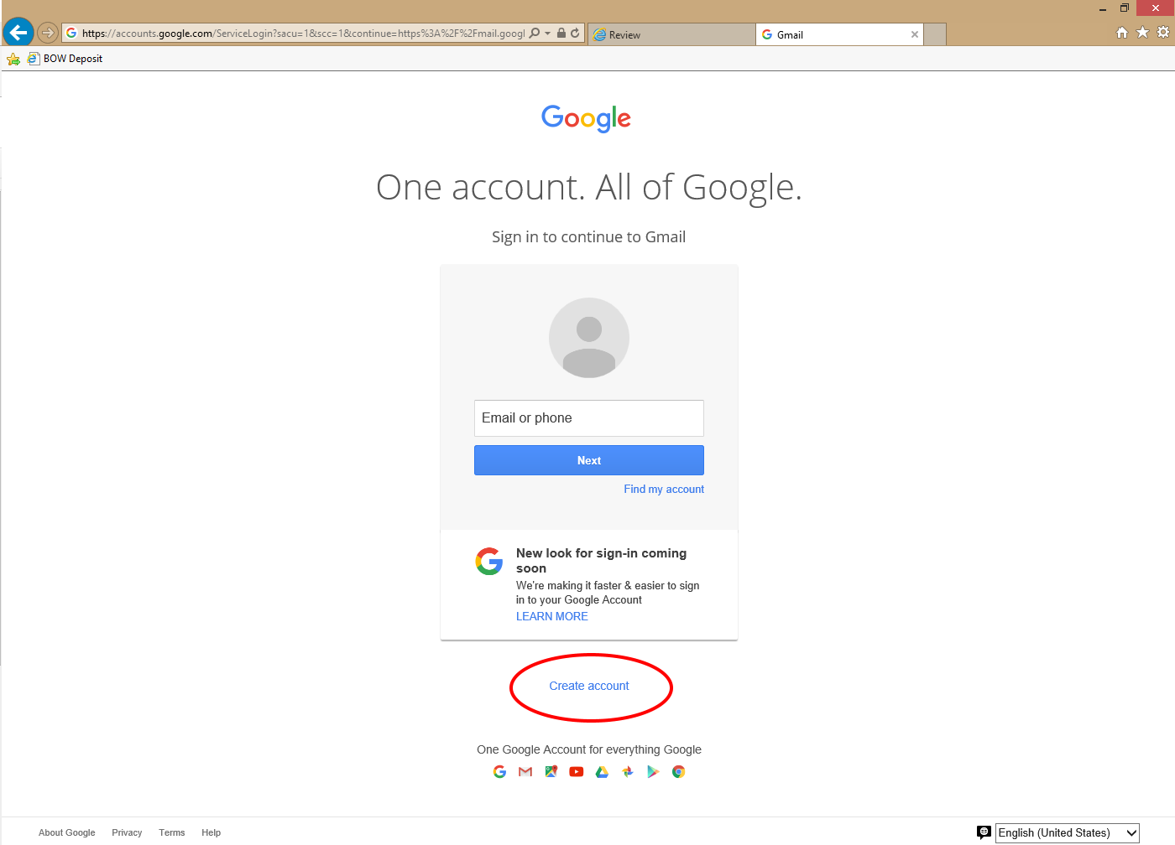
- Select “Create Account” from the login screen.

- Fill in your new account information on the “Create your Google Account” page.
  - You can either register with your actual name (first and last) or use ‘Foster Mom / Foster Family’ for a general name. In the example, we use “Foster Mom” for the first name and “Emily” for the last name.
  - You may wish to select an email address that has something to do with kittens and/or fostering, but it’s entirely up to you.
  - Click “Next step,” and it will take you to the confirmation page.
  - On the confirmation page, select ‘Continue to Gmail’
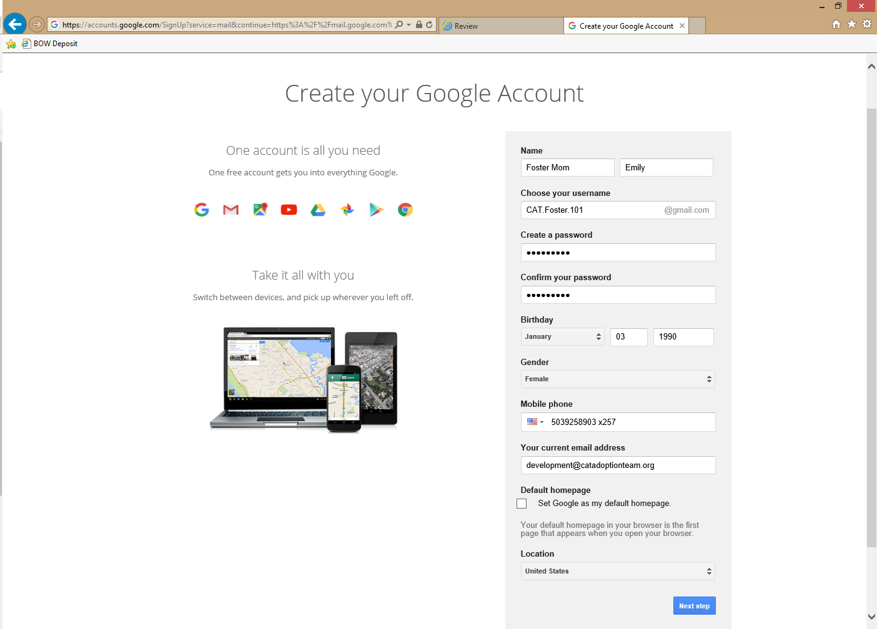
  - Select next step

Set up an automatic response

- In Gmail, go to your inbox and click on the gear icon on the upper right side of the screen.
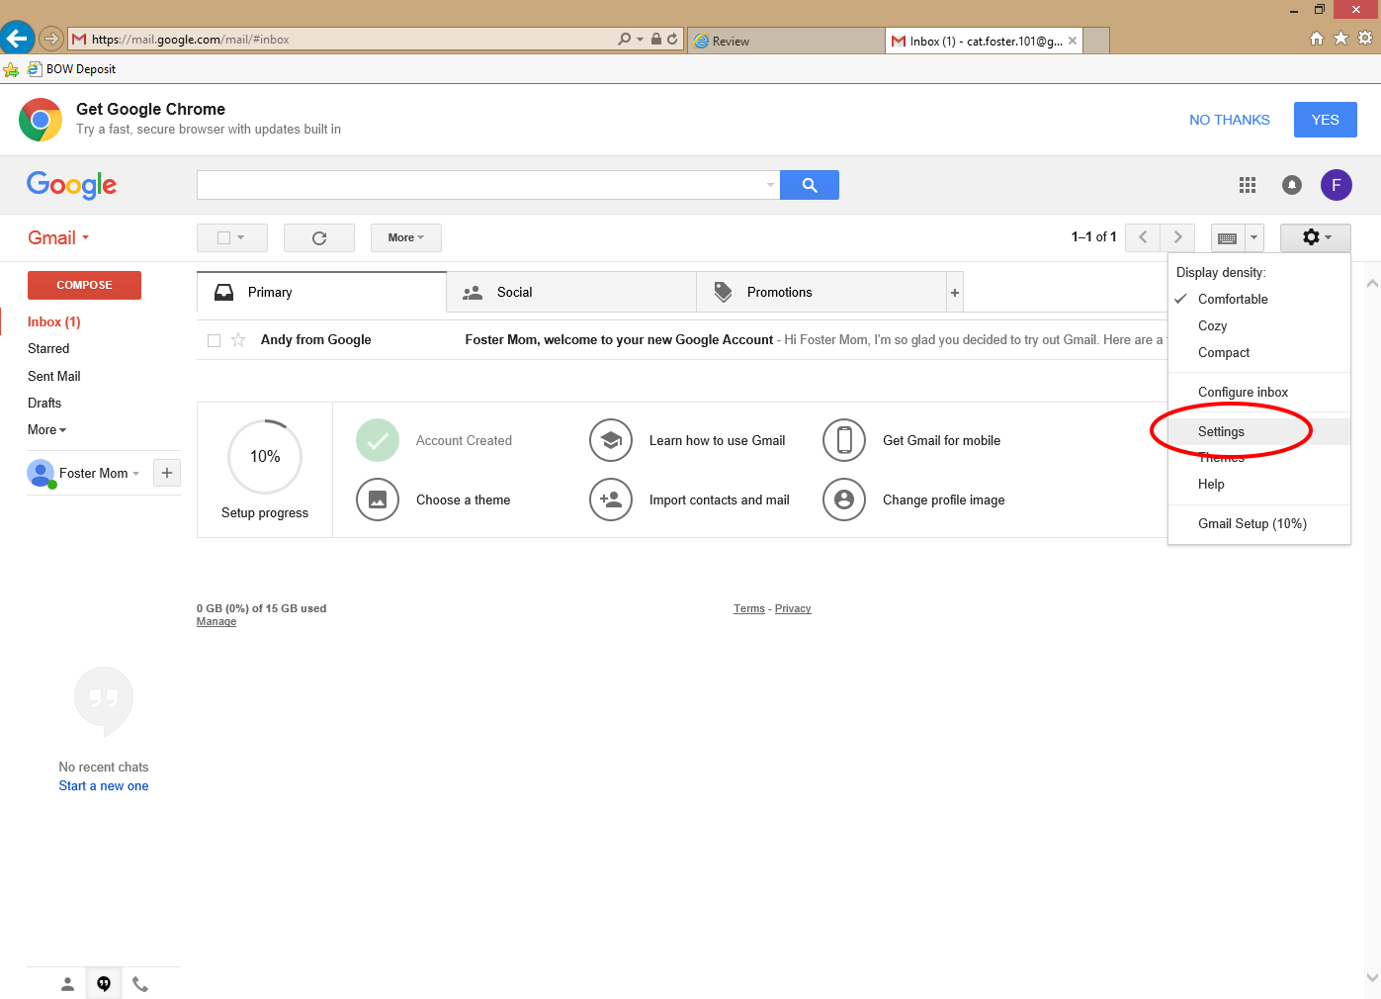
  - In the drop-down menu under the gear, select “Settings.”
- On the Settings page, scroll to the bottom to find the “Vacation responder” section.
  - Click the radial button next to “Vacation responder on” to turn on this feature.
  - Write your auto-response email using the text fields. For “First day:” use today’s date. You can leave the “Last day:” field blank, and the auto-response will stay on until you manually turn it off.
  - Be sure to include a subject line. In the “Subject:” field, you might use something like “Thank you for your interest in <<Mother cat’s name>>’s kittens” or “Thank you for your interest in <<kitten name(s)>>.
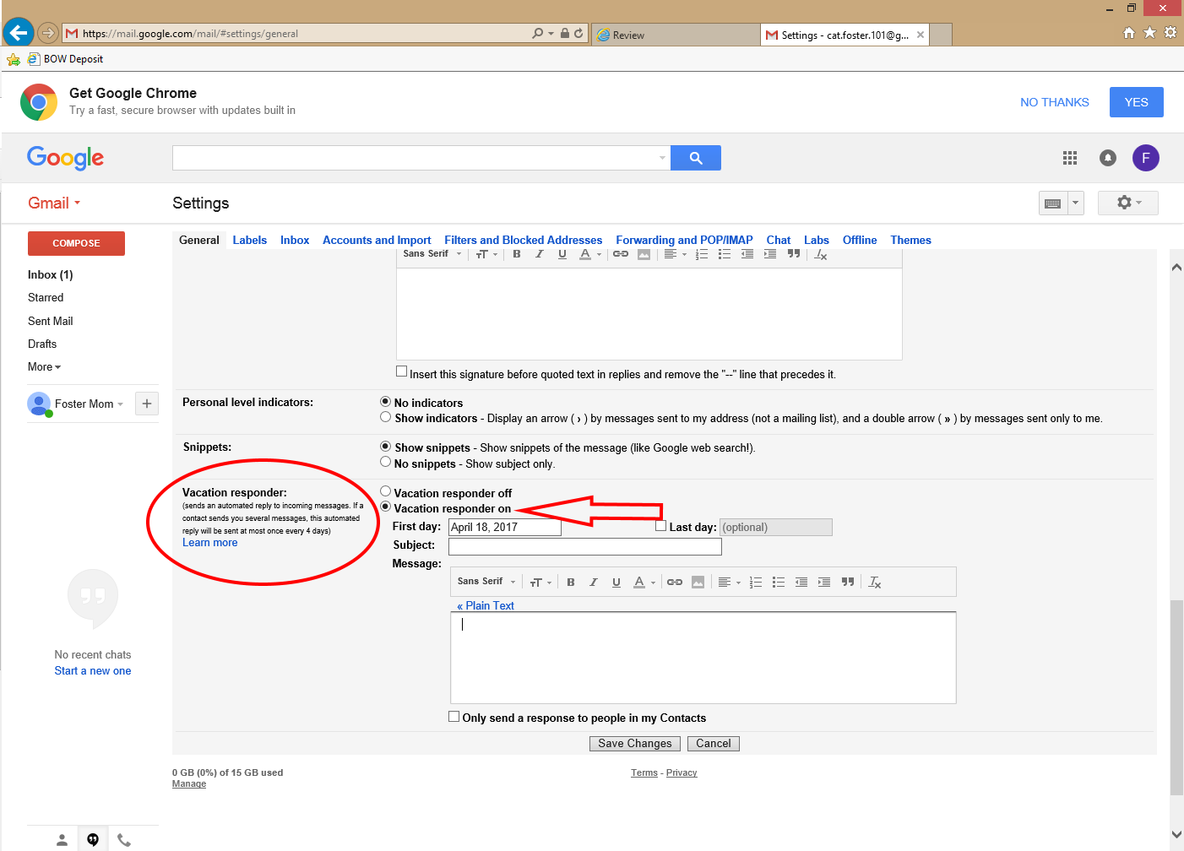
  - For the message, use one of the suggested auto-responses (see next page)
AUTO-RESPONSES – AVAILABLE FOR ADOPTION
MOTHER CAT & LITTER
Hello, and thank you for your interest in <<mother cat’s name>>’s kittens!

There are many families who would like to adopt them. I will respond to inquiries on a first-come, first-served basis within 36 hours to let you know which kittens are currently available. Depending on how many people are ahead of you, we will also schedule your visit to meet the kittens.

If we schedule a visit for you, it does not guarantee that a kitten(s) will still be available at that time. Once visits begin, I will try to keep you updated about which kittens are still available.

Kittens cannot be held/reserved via email. You must meet kittens in person before you can adopt. If you meet the kittens and decide to adopt, you must go to Your Organization to complete the adoption paperwork and pay the adoption fee to reserve the kitten(s).

The kittens will not be ready to go home with you until they are at least 8 weeks old, weigh 1.5 pounds, are healthy, and have been spayed/neutered. All cats/kittens from Your Organization are spayed/neutered before they can go home.

If you are unable to adopt one of <<mother cat’s name >>’s kittens, there may be other kittens ready for adoption soon! Please check Your Organization’s website for more information: Your Organization’s Website.

If you have any further questions, please don’t hesitate to ask.

Thanks again,
<<your name>>

LITTER WITH NO MOM
Hello, and thank you for your interest in <<kitten name(s)>>!

There are many families who would like to adopt them. I will respond to inquiries on a first-come, first-served basis within 36 hours to let you know which kittens are currently available. Depending on how many people are ahead of you, we will also schedule your visit to meet the kittens.

If we schedule an appointment for you, it does not guarantee that a kitten(s) will still be available at that time. Once visits begin, I will try to keep you updated about which kittens are still available.

Kittens cannot be held/reserved via email. You must meet kittens in person before you can adopt. If you meet the kittens and decide to adopt, you must go to Your Organization to complete the adoption paperwork and pay the adoption fee to reserve the kitten(s).

The kittens will not be ready to go home with you until they are at least 8 weeks old, weigh 1.5 pounds, are healthy, and have been spayed/neutered. All kittens from Your Organization are spayed/neutered before they can go home.

If you are unable to adopt one of my foster kittens, there may be other kittens ready for adoption soon! Please check Your Organization’s website for more information: Your Organization’s Website.

If you have any further questions, please don’t hesitate to ask. Thanks so much, and have a meowvelous day!

Thanks again,
<<your name>>

SINGLE KITTEN WITH NO MOM
Hello, and thank you for your interest in <<kitten name>>!

There are many families who would like to adopt him/her. I will respond to inquiries on a first-come, first-served basis within 36 hours. Depending on how many people are ahead of you, we will then schedule your visit to meet <<kitten name>>.

If we schedule an appointment for you to view the kittens, it does not guarantee that <<kitten name>> will still be available at that time. I will update you if s/he gets adopted.

Kittens cannot be held/reserved via email. You must meet in person before you can adopt. If you meet <<kitten name>> and decide to adopt, you will need to go to Your Organization to complete the adoption paperwork and pay the adoption fee to reserve <<kitten name>>.

Kittens cannot go home with you until they are at least 8 weeks old, weigh 1.5 pounds, are healthy, and have been spayed/neutered. All kittens from Your Organization are spayed/neutered before they can go home.

If you are unable to adopt <<kitten name>>, there may be other kittens ready for adoption soon! Please check Your Organization’s website for more information: Your Organization’s Website.

If you have any further questions, please don’t hesitate to ask. Thanks so much, and have a meowvelous day!

Thanks again,
<<your name>>

AUTO-RESPONSES – ADOPTED
MOTHER CAT & KITTEN(S)
Hello, and thank you for your interest in <<mother cat’s name>> kittens!

All of these kittens have been adopted, but Your Organization has many other wonderful cats and kittens awaiting their forever homes! To see cats and kittens currently available for adoption, visit Your Organization’s Website.

I am not checking this email address at this time. If you have any further questions, please contact Your Organization directly at Your Organization’s Website or Your Organization Phone Number.

Thank you,
<<your name>>
LITTER WITH NO MOM

Hello, and thank you for your interest in <<kittens’ names>>!

All of these kittens have been adopted, but Your Organization has many other wonderful cats and kittens awaiting their forever homes! To see cats and kittens currently available for adoption, visit Your Organization’s Website.

I am not checking this email address at this time. If you have any further questions, please contact Your Organization directly at Your Organization’s Website or Your Organization Phone Number.

Thank you,
<<your name>>

SINGLE KITTEN WITH NO MOM

Hello, and thank you for your interest in <<kitten’s name>>!

<<Kitten’s name>> has been adopted, but Your Organization has many other wonderful cats and kittens awaiting their forever homes! To see cats and kittens currently available for adoption, visit Your Organization’s Website.

I am not checking this email address at this time. If you have any further questions, please contact Your Organization directly at Your Organization’s Website or Your Organization Phone Number.

Thank you,
<<your name>>

